

**Lab task 6**

**CS 4-1 BSCS DATABASE**

**Name:** Sharaiz Ahmed **SAP:** 57288

**[Task 1]**

SELECT COUNT(*)

FROM emp

WHERE deptno = 30;

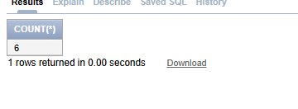

SELECT COUNT(DISTINCT deptno)

FROM emp;

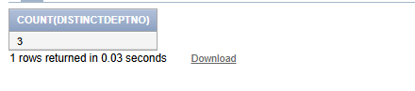

SELECT MIN(hiredate), MAX(hiredate)

FROM emp;

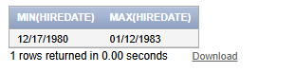

SELECT deptno, AVG(sal)

FROM emp

GROUP BY deptno;

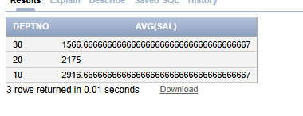

**[Task 2]**

SELECT AVG(sal)

FROM emp

WHERE LOWER(ename) LIKE '%a%'

AND LOWER(ename) LIKE '%e%';

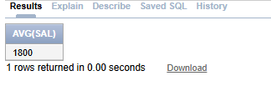

**[Task 3]**

SELECT

ROUND(MAX(sal), 2) AS Maximum,

ROUND(MIN(sal), 2) AS Minimum,

ROUND(SUM(sal), 2) AS Sum,

ROUND(AVG(sal), 2) AS Average

FROM emp;

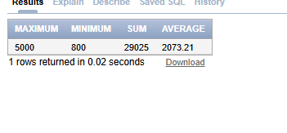

**[Task 4]**

SELECT

empno,

ROUND(MAX(sal), 2) AS Maximum,

ROUND(MIN(sal), 2) AS Minimum,

ROUND(SUM(sal), 2) AS Sum,

ROUND(AVG(sal), 2) AS Average

FROM emp

GROUP BY empno;

